**Chapter 4**

**Differentiation of Functions of Several Variables**

**4.7 Maxima/Minima Problems**

**Section Exercises**

**For the following exercises, find all critical points.**

1. 

Answer:

1. 

Answer: 

1. 

Answer: 

1. 

Answer:  

**For the following exercises, find the critical points of the function by using algebraic techniques (completing the square) or by examining the form of the equation. Verify your results using the partial derivatives test.**

1. 

Answer: 

1. 

Answer: Maximum at 

1. 

Answer: Relative minimum at 

1. 

Answer: Relative minimum at 

**For the following exercises, use the second derivative test to identify any critical points and determine whether each critical point is a maximum, minimum, saddle point, or none of these.**

1. 

Answer:  is a saddle point;  is a relative maximum.

1. 

Answer: The second derivative test fails. Since  for all *x* and *y* different from zero, and  when either *x* or *y* equals zero (or both), then the absolute minimum occurs at 

1. 

Answer:  is a local minimum.

1. 

Answer:  is a saddle point.

1. 

Answer:  the test is inconclusive.

1. 

Answer:   is a saddle point.

1. 

Answer:  is a local minimum, is a saddle point, is a saddle point, is a local maximum.

1. 

Answer:  is a local maximum.

1. 

Answer:  the test is inconclusive.

1. 

Answer: Relative minimum located at 

1. 

Answer:  is a relative minimum.

1. 

Answer:  is a saddle point.

1. 

Answer:  is a relative minimum.

1. 

Answer:  and  are saddle points;  is a relative minimum.

1. 

Answer:  is a saddle point.

1. 

Answer:  is a relative maximum.

1. 

Answer:  is a relative minimum.

1. 

Answer:  is a saddle point.

1. 

Answer:  is a relative maximum.

1. 

Answer: The relative maximum is at 

1. 

Answer: The relative minimum is at 

1. 

Answer:  is a saddle point and  is the relative minimum.

1. 

Answer: A saddle point is located at  there is a local maximum at  and there is a local minimum at 

**For the following exercises, determine the extreme values and the saddle points. Use a CAS to graph the function.**

1. **[T]** 

Answer: A saddle point is located at 

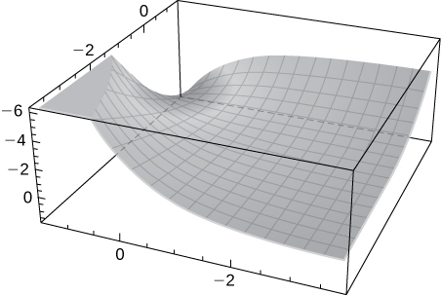

1. **[T]** 

Answer:  where  is an integer. These are saddle points. There are no relative extrema.

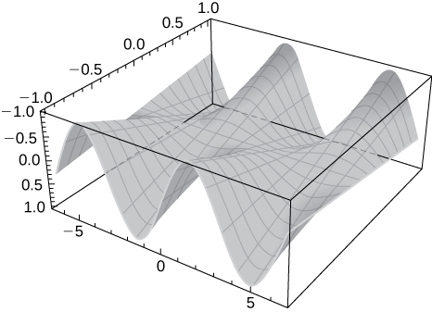

1. **[T]** 

Answer: There is a saddle point at  local maxima at  and local minima at 

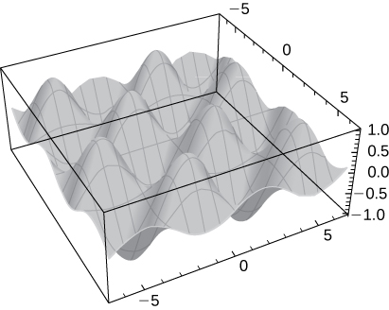

**Find the absolute extrema of the given function on the indicated closed and bounded set **

1.   is the triangular region with vertices (0, 0), (0, 4) and (5, 0).

Answer: The absolute maximum 0 is at (0, 0); the absolute minimum  is at .(0, 4).

1. Find the absolute maximum and minimum values of  on the region 

Answer: (0, 1, 0) is the absolute minimum and (0, -2, 9) is the absolute maximum.

1.  on 

Answer: Absolute minima are located at  and an absolute maximum is located at 

1.  on 

Answer: There is an absolute minimum at (0, 1, -1) and an absolute maximum at (0, -1, 1).

1. Find three positive numbers the sum of which is  such that the sum of their squares is as small as possible.

Answer: 

1. Find the points on the surface  that are closest to the origin.

Answer: 

1. Find the maximum volume of a rectangular box with three faces in the coordinate planes and a vertex in the first octant on the plane 

Answer:  cubic units

1. The sum of the length and the girth (perimeter of a cross-section) of a package carried by a delivery service cannot exceed  in. Find the dimensions of the rectangular package of largest volume that can be sent.

Answer:

1. A cardboard box without a lid is to be made with a volume of  ft3. Find the dimensions of the box that requires the least amount of cardboard.

Answer:  by  by  ft

1. Find the point on the surface  nearest the plane  Identify the point on the plane.

Answer: 

1. Find the point in the plane  that is closest to the origin.

Answer: 

1. A company manufactures two types of athletic shoes: jogging shoes and cross-trainers. The total revenue from units of jogging shoes and ** units of cross-trainers is given by  where  and are in thousands of units. Find the values of *x* and *y* to maximize the total revenue.

Answer:  and 

1. A shipping company handles rectangular boxes provided the sum of the length, width, and height of the box does not exceed  in. Find the dimensions of the box that meets this condition and has the largest volume.

Answer: The dimensions are  by  by  in. (a cube); the volume is  in.3.

1. Find the maximum volume of a cylindrical soda can such that the sum of its height and circumference is  cm.

Answer:  cm3

This file is copyright 2016, Rice University. All Rights Reserved.